**PIZZA SALES REPORT BY USING MY SQL**

1. **KPI'S :**

**1.TOTAL REVENUE**

SELECT ROUND(SUM(TOTAL_PRICE),2) AS TOTAL_REVENUE

FROM PIZZA_SALES;

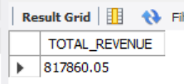

**2. AVG ORDER VALUE**

SELECT ROUND(SUM(TOTAL_PRICE)/ COUNT(DISTINCT ORDER_ID),2) AS AVG_ORDER_VALUE

FROM PIZZA_SALES;

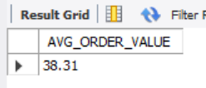

**3. TOTAL PIZZAS SOLD**

SELECT SUM(QUANTITY) AS TOTAL_PIZZAS_SOLD

FROM PIZZA_SALES;

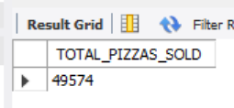

**4.TOTAL NUMBER OF ORDERS**

SELECT COUNT(distinct ORDER_ID) AS TOTAL_ORDERS

FROM PIZZA_SALES;

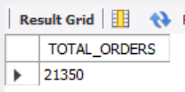

**5. AVG PIZZAS PER ORDER**

SELECT SUM(QUANTITY)/COUNT(distinct ORDER_ID) AS AVG_PIZZAS_PER_ORDER

FROM PIZZA_SALES;

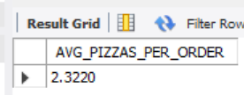

1. **VISUALIZATIONS :**

**1.DAILY TREND FOR TOTAL ORDERS**

SELECT dayname(ORDER_DATE) AS DAY, COUNT(DISTINCT ORDER_ID) AS TOTAL_ORDERS

FROM PIZZA_SALES

GROUP BY dayname(ORDER_DATE);

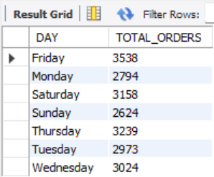

**2.MONTHLY TREND FOR DAILY ORDERS**

SELECT monthname(ORDER_DATE) AS MONTH_NAME,COUNT(DISTINCT ORDER_ID) AS TOTAL_ORDERS

FROM PIZZA_SALES

GROUP BY monthname(ORDER_DATE)

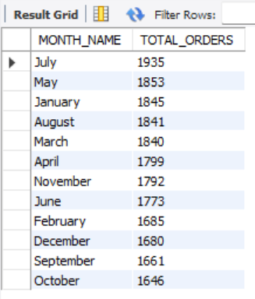ORDER BY TOTAL_ORDERS DESC;

**3. PERCENTAGE OF SALES BY PIZZA CATEGORY**

SELECT PIZZA_CATEGORY, CONCAT(ROUND((SUM(TOTAL_PRICE)/(SELECT SUM(TOTAL_PRICE) FROM PIZZA_SALES))*100,2),"%") AS PERC_TOTAL_SALES

FROM PIZZA_SALES

GROUP BY PIZZA_CATEGORY;

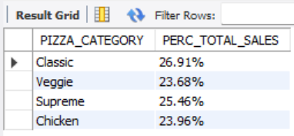

**4. PERCENTAGE OF SALES BY PIZZA SIZE**

SELECT PIZZA_SIZE ,CONCAT(ROUND((SUM(TOTAL_PRICE)/(SELECT SUM(TOTAL_PRICE) FROM PIZZA_SALES))*100,2),"%") AS PERC_TOTAL_SALES

FROM PIZZA_SALES

GROUP BY PIZZA_SIZE

ORDER BY PERC_TOTAL_SALES ;

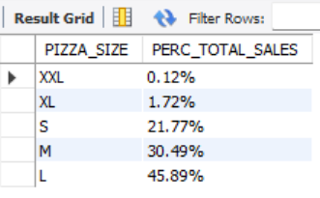

**5. TOTAL PIZZA SOLD BY PIZZA CATEGORY**

SELECT PIZZA_CATEGORY,SUM(QUANTITY) AS TOTAL_PIZZA_SOLD

FROM PIZZA_SALES

GROUP BY PIZZA_CATEGORY;

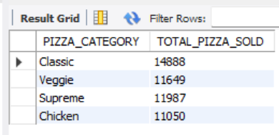

1. **TOP 5 BEST & WORST SELLERS :**

**1. TOP 5 BEST SELLERS BY TOTAL PIZZAS SOLD**

SELECT PIZZA_NAME ,SUM(TOTAL_PRICE) AS TOTAL_REVENUE

FROM PIZZA_SALES

GROUP BY PIZZA_NAME

ORDER BY TOTAL_REVENUE DESC

LIMIT 5;

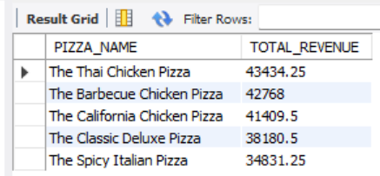

**2. BOTTOM 5 BEST SELLERS BY TOTAL PIZZAS SOLD**

SELECT PIZZA_NAME ,SUM(TOTAL_PRICE) AS TOTAL_REVENUE

FROM PIZZA_SALES

GROUP BY PIZZA_NAME

ORDER BY TOTAL_REVENUE

LIMIT 5;

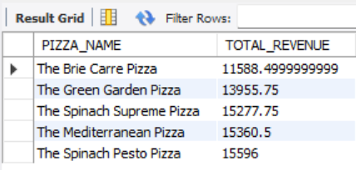

**3. TOP 5 BEST SELLERS BY TOTAL PIZZAS QUANTITY**

SELECT PIZZA_NAME ,SUM(QUANTITY) AS TOTAL_QTD

FROM PIZZA_SALES

GROUP BY PIZZA_NAME

ORDER BY TOTAL_QTD DESC

LIMIT 5;

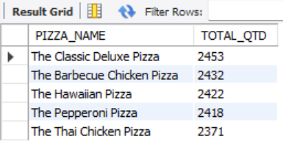

**4. BOTTOM 5 BEST SELLERS BY TOTAL PIZZAS QUANTITY**

SELECT PIZZA_NAME ,SUM(QUANTITY) AS TOTAL_QTD

FROM PIZZA_SALES

GROUP BY PIZZA_NAME

ORDER BY TOTAL_QTD

LIMIT 5;

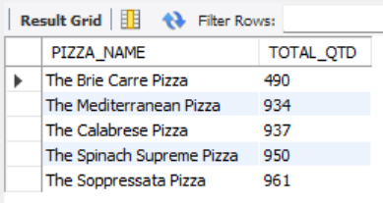

**5. TOP 5 BEST SELLERS BY TOTAL PIZZAS ORDER_COUNT**

SELECT PIZZA_NAME ,COUNT(DISTINCT ORDER_ID) AS TOTAL_ORDERS

FROM PIZZA_SALES

GROUP BY PIZZA_NAME

ORDER BY TOTAL_ORDERS DESC

LIMIT 5;

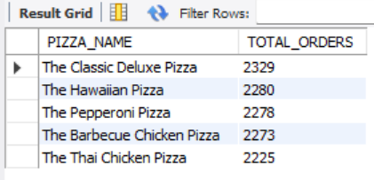

**6. BOTTOM 5 BEST SELLERS BY TOTAL PIZZAS ORDER_COUNT**

SELECT PIZZA_NAME ,COUNT(DISTINCT ORDER_ID) AS TOTAL_ORDERS

FROM PIZZA_SALES

GROUP BY PIZZA_NAME

ORDER BY TOTAL_ORDERS

LIMIT 5;

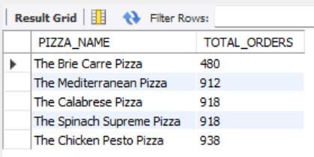

* **To filter results based on pizza_category or pizza_size, you can use the WHERE clause in your queries. Below are some examples demonstrating its usage :-**

1. SELECT PIZZA_NAME , COUNT(DISTINCT ORDER_ID) AS TOTAL_ORDERS

FROM PIZZA_SALES

WHERE pizza_category = 'Classic'

GROUP BY PIZZA_NAME

ORDER BY TOTAL_ORDERS

LIMIT 5;

2. SELECT PIZZA_NAME, COUNT(DISTINCT ORDER_ID) AS TOTAL_ORDERS

FROM PIZZA_SALES

WHERE pizza_size = “L”

GROUP BY PIZZA_NAME

ORDER BY TOTAL_ORDERS

LIMIT 5;

Project by,

**Anshul Funde**| Email: [fundeanshul44@gmail.com](mailto:fundeanshul44@gmail.com) |

LinkedIn: www.linkedin.com/in/anshul-funde-1386261a4